**GENERAL INTEGRATED SCIENCE**

**UNIT 4**

**Task 7 – Chemical Reactions, mixtures and solutions test**

NAME: ______________________________

DUE DATE: ______________________________ WEIGHTING: 10 %

TEACHER: ______________________________ MARK: ___ / 69 = _____ %

Important Information for Students

1. There are TWO sections in this test - Multiple Choice and Short Answer.
2. This is a closed-book assessment (no notes are allowed)
3. The time allowed to complete the test is 55 minutes.
4. Write your answers to the Multiple Choice section in the space provided. Circle only 1 answer.
5. Write your answers to the Short Answer section in space provided.

|  |  |  |
| --- | --- | --- |
| **Sections** | **Marks Allocation** | **Your Total** |
| **A - Multiple Choice** | 9 |  |
| **B - Short Answer** | 59 |  |
| **TOTAL** | 68 |  |

**Multichoice Questions  *(10 Marks)***

**Circle** the letter that represents the best answer from the choice of answers. Marks are not deducted for wrong answers.

1. Which of the following is NOT matter?
2. Humans
3. Air
4. Energy
5. Exhaust fumes
6. Compounds are combined ________ while mixtures are combined ________.
7. chemically, physically
8. physically, chemically
9. strongly, weakly
10. weakly, strongly
11. Which of the following numbers on the pH scale represents a strongly alkaline substance?
12. pH 1
13. pH 3
14. pH 8
15. pH 14
16. Soaps and detergents are:
    1. emulsifiers
    2. acidic
    3. made of two hydrophobic ends
    4. made of two hydrophilic ends
17. Which of the following is true about acids?
18. They have a high pH (>7)
19. They are alkaline
20. They release hydroxide ions into water
21. They release hydrogen ions into water
22. A chemical reaction can only begin when
23. Enough activation energy is supplied
24. Oxygen is present
25. Activation energy is removed
26. The chemical bonds in the reactants are still intact
27. You’re cooking a steak on a hot, dry grill. It starts to turn a delicious brown colour on the outside. What is the name of the chemical reaction that causes this?
28. Burning
29. Malliard
30. Caramelisation
31. Enzymatic Browning
32. Which separation method is used to separate a mixture based on the components density?
33. Distillation
34. Decantation
35. Chromatography
36. Evaporation
37. Sodium bicarbonate is reacted with citric acid in an **open** beaker. It produces carbon dioxide, water and a salt. After the reaction, the beaker will weigh:
    1. The same as the reactants
    2. More than the reactants
    3. It is impossible to test the weight of the products
    4. Less than the reactants

**Short Answer Section (58 marks)**

**Question 1. *(3 marks)***

List three observations that would reveal that a chemical reaction has occurred

______________________________________________________________________ ______________________________________________________________________

**Question 2. *(2 marks)***

Explain the difference between a homogenous and a heterogeneous mixture ______________________________________________________________________ ______________________________________________________________________ ______________________________________________________________________

**Question 3.  *(6 marks)***

You are trying to make a hard candy, so you add a few tablespoons of sugar to a litre of cold tap water. After leaving your solution for a few days, you’re disappointed to find that it is still runny.

1. Explain two changes that you should make to your method to make hard candy *(4 marks)*

______________________________________________________________________ ______________________________________________________________________ ______________________________________________________________________

1. Circle the correct option. To make hard candy, the sugar-water solution must be *(1 mark*):

Dilute Saturated Supersaturated

1. Does the kind of solution from part b have more solute or solvent? _____________ *(1 mark)*

**Question 4. *(2 marks)***

Describe the relationship between enzymes, activation energy and chemical reactions.

______________________________________________________________________ ______________________________________________________________________ ______________________________________________________________________

**Question 5. *(4 marks)***

You make some sherbet by mixing citric acid, icing sugar and sodium bicarbonate.

1. What kind of acid reaction is occurring when you eat the sherbet? *(1 mark)*
2. What is the general word equation for this kind of reaction? *(1 mark)*

______________________________________________________________________

1. Explain why this reaction would make your mouth feel cold *(2 marks).*

______________________________________________________________________ ______________________________________________________________________

**Question 6. (*6 marks)***

1. An unknown liquid was spilled in the kitchen. There are three containers on the floor; one is a water bottle, one is a strong acid used in cooking and one is a strong base used for cleaning. How would you accurately determine which substance has been spilt? *(4 marks)*

______________________________________________________________________ ______________________________________________________________________ ____________________________________________________________________________________________________________________________________________ ______________________________________________________________________ ______________________________________________________________________

1. Discuss why it is important to determine which substance was spilt in order to safely clean-up the mess *(2 marks)*

______________________________________________________________________ ______________________________________________________________________ ____________________________________________________________________________________________________________________________________________ ______________________________________________________________________ ______________________________________________________________________

**Question 7. *(3 marks)***

Match the following terms with the correct example

**Mayonnaise**

**Emulsion**

**Suspension**

**Homogenous Mixture**

**Salt Water**

**Salad Dressing**

**Question 8. *(5 marks)***

1. 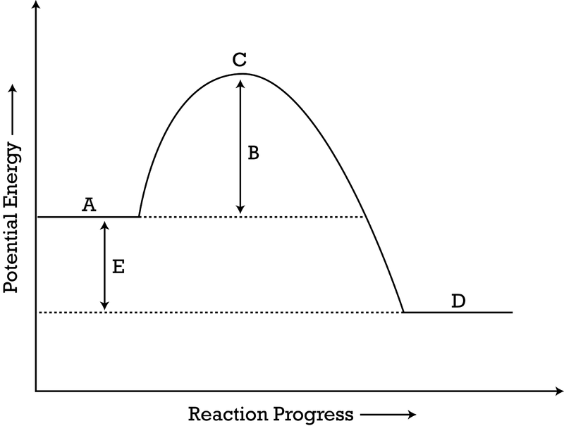On the following diagram, label the activation energy, the reactants and the products.
2. Given that there is no scale on the Y-axis, discuss whether this reaction would be dangerous to be near *(3 marks).*

______________________________________________________________________ ______________________________________________________________________ ______________________________________________________________________

**Question 9. *(7 marks)***

Salami is made by compressing meat, adding bacteria and hanging the mixture in a dry environment to remove excess water.

1. Through what process is the water leaving the salami? *(1 mark)* ________________
2. Predict why the best-tasting and most expensive salamis have been left to hang for a longer period of time *(2 marks).*

___________________________________________________________________ ______________________________________________________________________________________________________________________________________

1. Bacteria is also used to make cheese. These bacteria undergo a form of respiration called fermentation, which is a chemical reaction that allows these bacteria to make energy. Name two other foods that use fermentation during their production *(2 marks).*

_______________________________ ____________________________________

1. The term fermentation is based on a word that means ‘to bubble’. Given your understanding of chemical reactions, explain why fermentation might produce bubbles *(2 marks).*

___________________________________________________________________ ___________________________________________________________________ ___________________________________________________________________

**Question 10 *(5 marks)***

1. List two physical properties of orange juice *(2 marks*).

__________________________________ ___________________________________

1. Orange juice normally tastes sweet, but taste sour after brushing your teeth. Explain whether the properties of the orange juice change after you brush your teeth? *(2 marks)* _________________________________________________________________ _________________________________________________________________
2. Suggest how the flavour of orange juice could change in this way *(1 mark).*

______________________________________________________________________

**Question 11 *(4 marks)***

In the food production process there are many chemical reactions that occur. Use the picture below to answer the following questions.

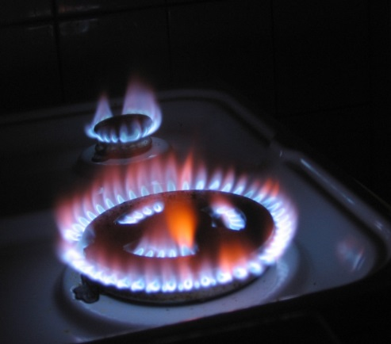

1. What reaction type is being represented in the picture of a gas stove top? *(1 mark)*
2. Is this reaction endothermic or exothermic? *(1 mark)*
3. What are the reactants in this reaction? *(1 mark)*

_________________________________________________________________

1. What are the products in this reaction? *(1 mark)* _________________________________________________________________

**Question 12 *(11 marks)***

You want to make a healthy soup for your family to try. You add red cabbage, water, and salt to a pot and allow them to cook for a few minutes. While you’re waiting, you remember that Apple Cider Vinegar is very healthy and decide to add some to the soup mixture. You accidentally add way too much, and to your shock, the soup turns red!

1. Briefly explain this colour change *(2 marks)*.

______________________________________________________________________ ______________________________________________________________________

1. The vinegar has a pH of 2.8. Describe what *would* happen to the soups pH if you added a few tablespoons on sodium bicarbonate *(3 marks).*

______________________________________________________________________ ______________________________________________________________________

You decide to start your soup again, but don’t want to waste the ingredients. Design a procedure that would enable you to remove the red cabbage, vinegar, and salt from the water. You will need to outline the separation technique you would use, and which chemical/physical property this technique is based on. Make sure that you use the scientific names for all procedures *(6 marks).*

___________________________________________________________________ ___________________________________________________________________ ______________________________________________________________________________________________________________________________________ ___________________________________________________________________ ___________________________________________________________________

___________________________________________________________________ ___________________________________________________________________ ___________________________________________________________________

___________________________________________________________________ ___________________________________________________________________ ___________________________________________________________________

___________________________________________________________________ ___________________________________________________________________ ___________________________________________________________________

___________________________________________________________________ ___________________________________________________________________ ___________________________________________________________________

___________________________________________________________________ ___________________________________________________________________ ___________________________________________________________________

___________________________________________________________________ ___________________________________________________________________ ___________________________________________________________________

___________________________________________________________________ ___________________________________________________________________ ___________________________________________________________________